**11. ReactJs – HOL**

**1. Explain React events**

* React events are triggered in response to user interactions like clicks or input changes.
* They are similar to DOM events but follow React’s own system.
* React wraps events in a cross-browser wrapper called SyntheticEvent**.**

**2. 3Explain about event handlers**

* Event handlers are functions that respond to events like onClick or onChange.
* In React, handlers are passed as props using camelCase, e.g., onClick={handleClick}.
* They are usually defined as arrow functions or class methods.

**3. Define Synthetic event**

* SyntheticEvent is React's wrapper around the browser’s native event.
* It ensures consistent behavior across different browsers.
* Synthetic events pool and reuse event objects for performance optimization.

**4. Identify React event naming convention**

* React uses camelCase for event names (e.g., onClick, onSubmit).
* The handler value must be a function (not a string like in HTML).
* Example: <button onClick={handleClick}>Click</button>.

**React Application – eventexamplesapp**

Create a React Application “eventexamplesapp” to handle various events of the form elements in HTML.

1. Create “Increment” button to increase the value of the counter and “Decrement” button to decrease the value of the counter. The “Increase” button should invoke multiple methods.
   1. To increment the value
   2. Say Hello followed by a static message.

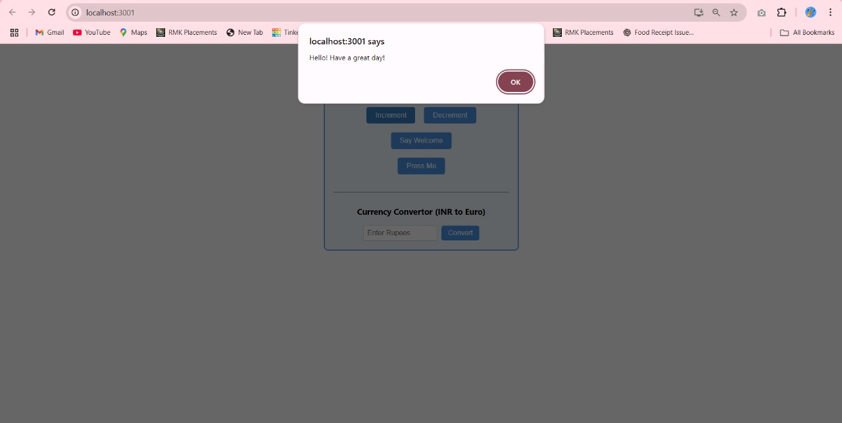

1. Create a button “Say Welcome” which invokes the function which takes “welcome” as an argument.

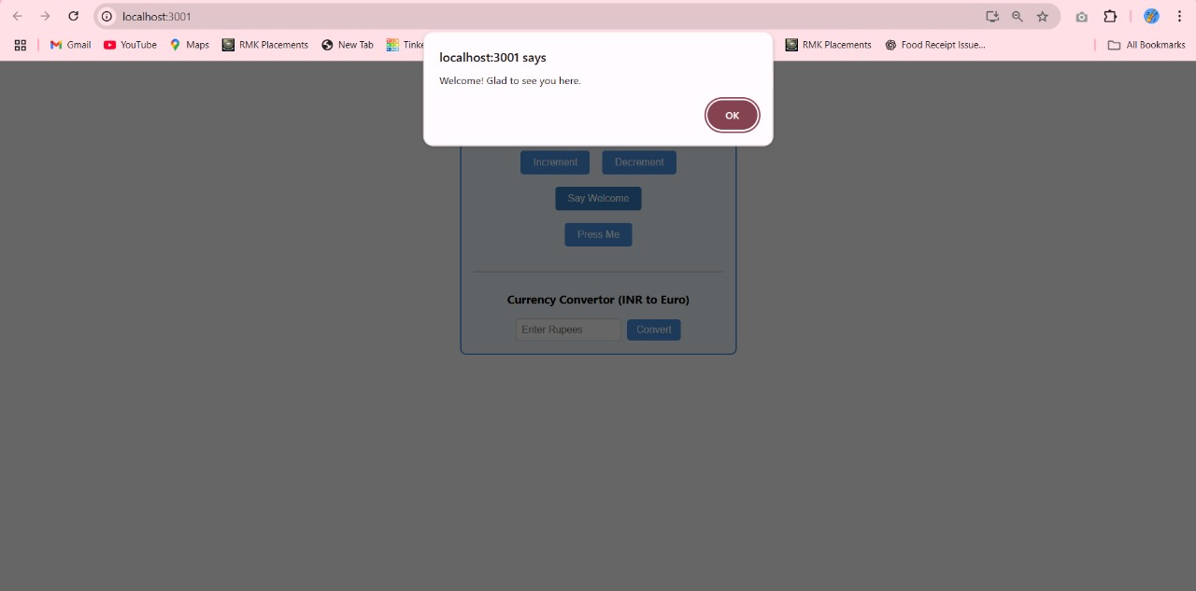

1. Create a button which invokes synthetic event “OnPress” which display “I was clicked”

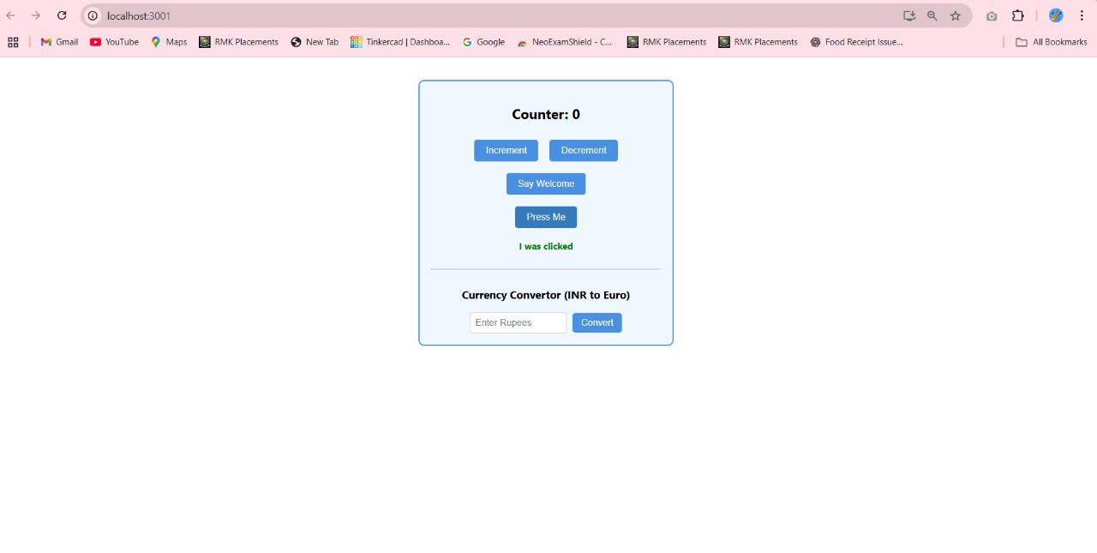

Create a “CurrencyConvertor” component which will convert the Indian Rupees to Euro when the Convert button is clicked.

Handle the Click event of the button to invoke the handleSubmit event and handle the conversion of the euro to rupees.

